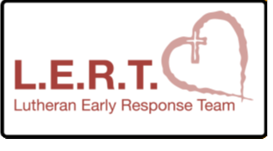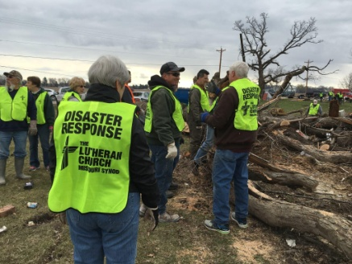

Be Part of our Team
This training will help us be ready to help our neighbors when disasters such as tornados or floods occur in our community. We are looking for High School students and adults to serve on this team
When: Saturday, May 12th
Time: 9:00 am till 3:00 pm (snacks & lunch provided)
Where: St. John Lutheran Church
655 Wayne Ave.
Defiance, Ohio 43512

Cost: $35 for training (only LCMS adult members will be certified)
$15 for youth 16-18 years of age

Contact Person: Angie Morris, Youth Director
419/782-5766 church office

Registrations: Due by Friday, April 27th
www.stjohndefiance.com/volunteer

Our trainer, Pastor Michael Meyer, will lead us through a Christ-like response to aid others through our words and deeds.

Registration for LERT
May 12th at St. John Lutheran, Defiance

____ Youth 16-18 yrs on date of training $15
____ 18+ on day of training $35

Name: ______________________________ Gender: Male / Female
Street: _______________________________________________________
City: _____________________ State: _________ Zip: ________________
Church: _____________________________ City: _____________________

Email: ________________________________________________________
Home phone: __________________________________________________
Cell phone: ____________________________________________________
Emergency contact name: ______________________ Phone: ____________

Occupation: ___ Student ___ Retired ___ Other:______________ Trades/Vocatons: _______________________________________________

Experience/Certifications:
___ CPR certification ___ EMT ___ Firefighter
___ First Aid/Medical ___ Police Officer ___ HAM radio
___ Red Cross Trg ___ Stephen Minister ___ AED
___ Pet First Aid ___ Incident Command ___ ACLS

Interested in going to Texas in late June? _____ Yes _____ No

